Bug Report
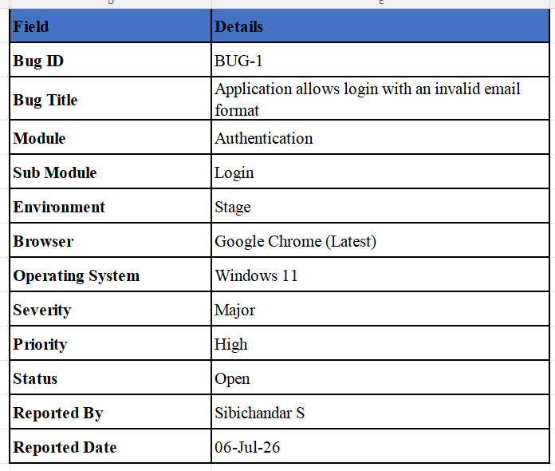

Summary
The Login page accepts an invalid email format and allows the user to continue instead of displaying an email validation error.

Description
The application does not validate the email format before processing the login request. An email containing consecutive dots (..) in the local part is accepted.

Preconditions
• Application is accessible.
• User is on the Login page.
• Internet connection is available.

Test Data
Email: sibi..chandar123@gmail.com
Password: test@123

Steps to Reproduce
1. Launch the application.
2. Navigate to Login.
3. Enter invalid email.
4. Click Continue.
5. Enter password.
6. Click Login.

Expected Result

The application should display an appropriate email validation error message and should not allow the user to proceed to the Register page

.Actual Result
Application accepts the invalid email format and proceeds.

Impact
Invalid data accepted, validation bypassed and poor user experience.

Possible Root Cause
Missing or incorrect client/server-side email validation.

Suggested Fix
Validate email using a standard regex on both client and server side.

Attachments
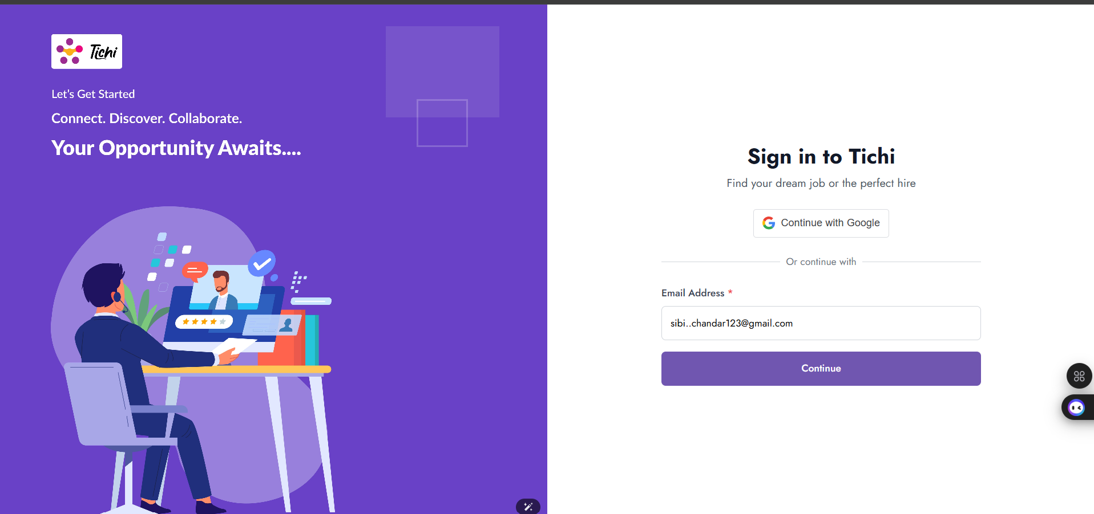
Screenshot 1:

Screenshot 2:
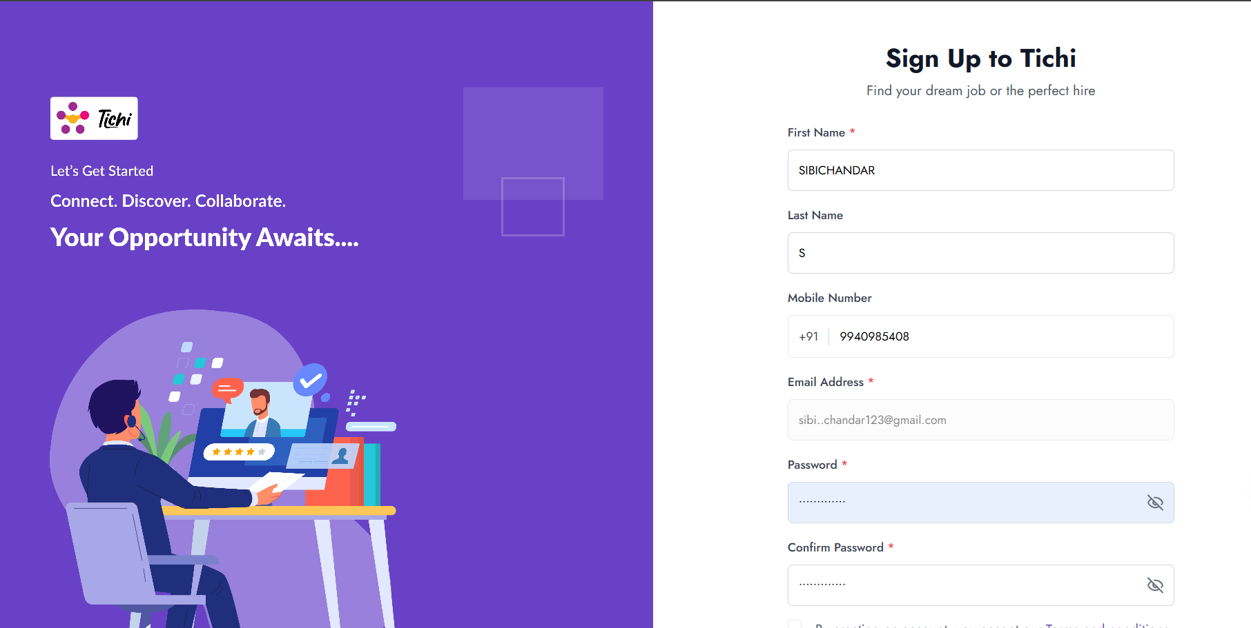

Note
Prepared for the assignment scenario.

